Task-Based Usability Testing

* Goals/Objectives
  + Most important things that every user must be able to do with our system?
  + Goals → Evaluation Tasks
* Tasks/Subtasks (and how they are measured)
  + Measures/Metrics
    - 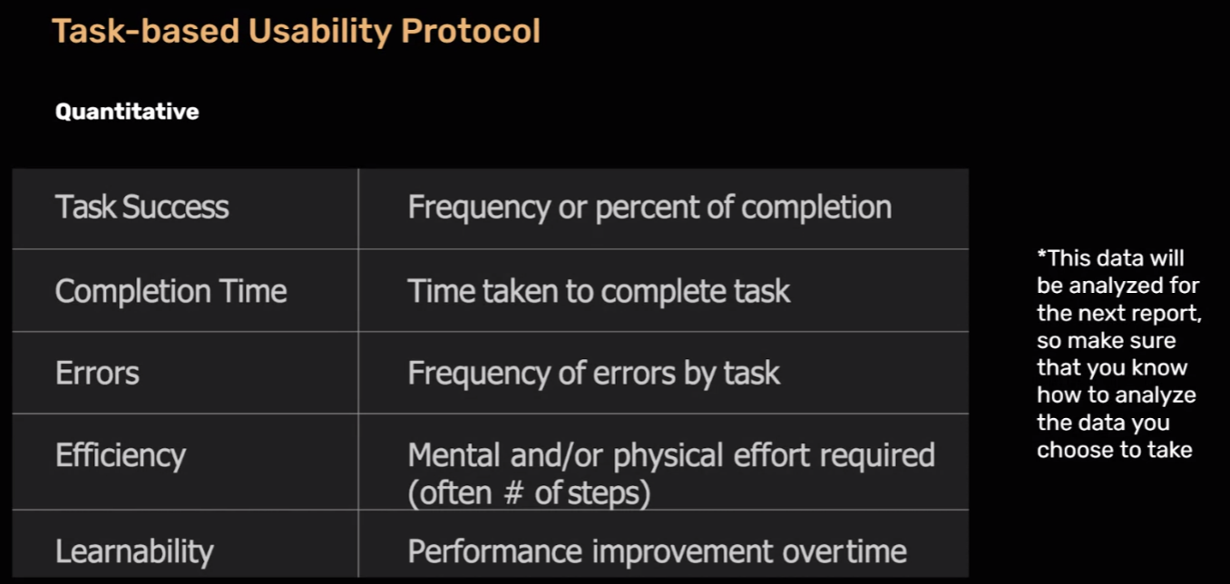
* Procedure/Methodology
  + Recruitment, participate description
    - How will you choose your participants? How will you collect demographic info? How does it connect to your stakeholders?
  + Prototype and how it relates to your task
    - Explain why you chose your design to accomplish the task?
  + Roles- what each member is doing
    - Who will facilitate? Who will take notes? Who is on tech support? Materials Used
  + Intro Script
    - For consistency, the test should be started and facilitated the same way. Intro yourselves, the test, safety disclosures
  + Note Taking Template
    - Tasks and measurements log, participant info section, should be the same for all tests for consistency
  + Consent Form
    - People can be sensitive about this process. Errors are likely to occur and as researchers it is up to you to make sure the participants know that their data is safe and that they can end the evaluation at any time.

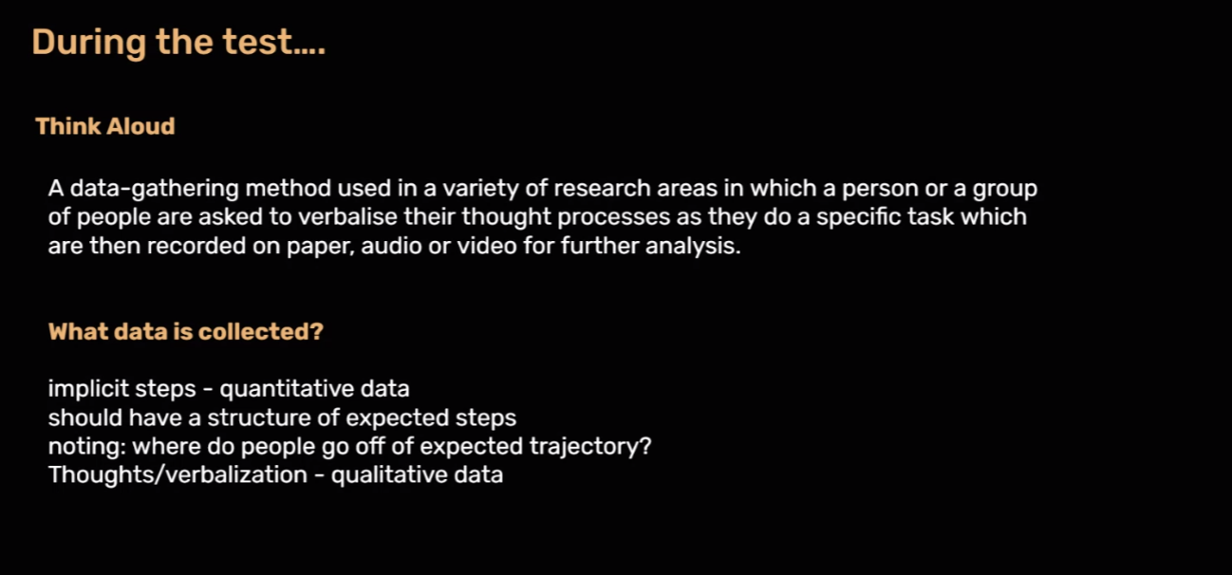

Tasks Examples:

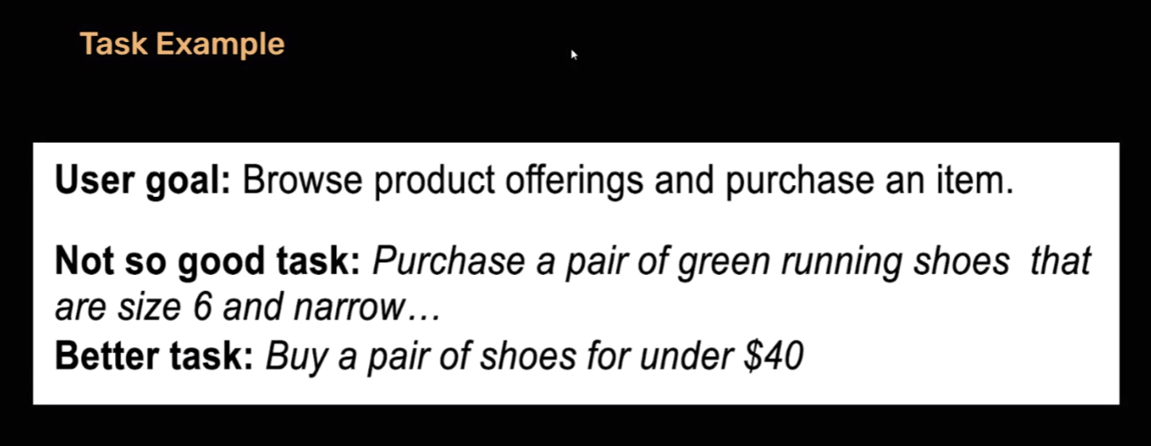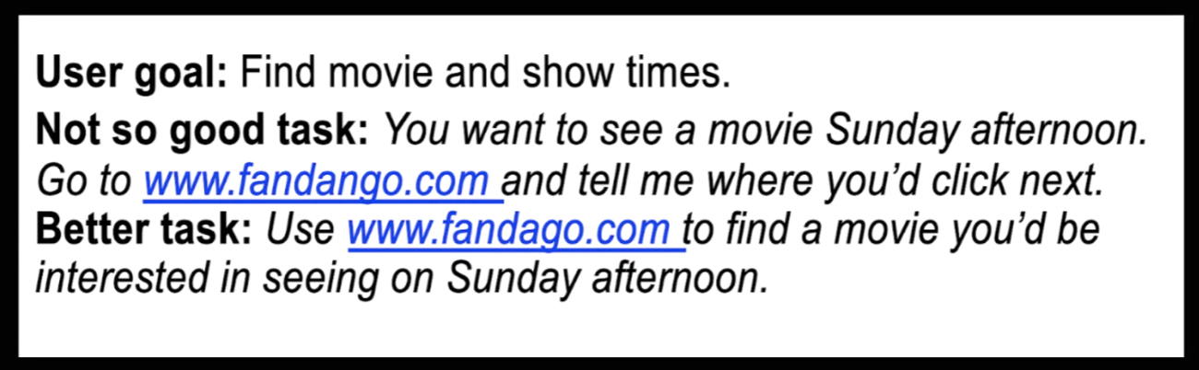

Script Example:

<https://docs.google.com/document/d/1IVprUr2DUaVBNZLCM-CcNEp69crQfV2TPthKlgGQUQM/edit?usp=sharing>